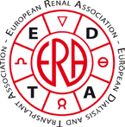
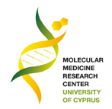
ERA-EDTA CME COURSE
“Recent breakthroughs in immunonephrology and inherited kidney diseases with emphasis on hematurias”
March 28-29, 2014, Nicosia, Cyprus
In collaboration with Immunonephrology Working Group (IWG) and Working Group on Inherited Kidney Diseases (WGIKD) of the ERA-EDTA

ORGANIZER
PROFESSOR CONSTANTINOS DELTAS
Director, Molecular Medicine Research Centre
Tel: +357-22-892882 E-mail: Deltas@ucy.ac.cy, http://www.ucy.ac.cy/mmrc

_____________________________________________________________________
REGISTRATION FORM
REGISTRATION IS FREE (NO REGISTRATION FEE)
NAME: ……………………………………………………………………………………………………………..
ADDRESS: ………………………………………………….……………………………………………………..
………………………………………………………………………………………………………..
TEL: ..................................................…… EMAIL: …………………………………..……..
POSITION: ………………….……………………….
DATE OF ARRIVAL: …..…………………………. DATE OF DEPARTURE: ….……………….
If you need assistance for your accommodation, contact:
Mrs Photoulla Antoniou: photoulla.antoniou@topkinisis.com
For any other assistance and information, contact:
Prof. C. Deltas: deltas@ucy.ac.cy OR Anna Christou: christou.anna@ucy.ac.cy
A small number of travel grants to young participants for best abstracts will be available (≤ 35y). For travel grant applications visit: http://www.era-edta.org/cme2014/Travel_Grant_Nicosia_2014.pdf
_____________________________________________________________________
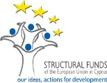
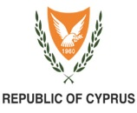
Please send your complete registration form preferably before March 15, 2014, to: Anna Christou, E-mail: christou.anna@ucy.ac.cy

