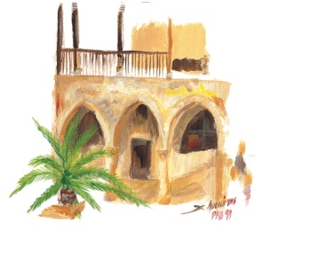

University of Cyprus Cultural Festival
Application Form
Dear artists,
Thank you for your interest in participating in the Cultural Festival of the University of Cyprus.
In order to present your artistic proposal more comprehensively and ensure its proper evaluation, please fill in all the fields in the form below.
1. Applicant Name – Artist/Group
_____________________________________________________________________
_____________________________________________________________________

2. Contact person
Full name:
Capacity:
Mobile phone:
E-mail:

3. Type of the proposed event
Concert Theatre performance
Music and dance performance Exhibition
Lecture Other artistic project
Other (please specify)

4. Title of the proposed event
_____________________________________________________________________
_____________________________________________________________________
5. Names and capacity of contributors
For instrumentalists, please specify also the instrument played.

6. Brief presentation of the proposed event
Note: If the proposal is accepted, this text will be used in the booklet containing the full programme of the Cultural Festival.

7. Proposed date of the event

Please note that the Cultural Festival takes place from early June to mid-July (Part A) and from early September to mid-October (Part B).

8. Brief presentation of the artist/group
Please describe briefly the background and development of the artist/group so far, mentioning the most important performances, collaborations, productions and anything else you consider useful for a more comprehensive presentation of your work.

Attachments:
CVs Photos
CDs Links to YouTube and other websites
Reviews in the press or on the internet Visual material, posters, etc.
Other (specify)

9. Financial details of the proposed event
Please indicate the costs of the performance that you expect to be covered within the framework of the Cultural Festival, bearing in mind that the Cultural Centre of the University of Cyprus does not cover production costs (e.g. rehearsal costs).
A. Expected artist fee (in euros)
B. Transportation costs of contributors from abroad (air tickets)
Number of people:
Route:
Arrival date:
Departure date:
Musical instruments to be transported by air (if applicable):

Note: The transportation costs will be calculated by the organisers of the Cultural Festival based on the above data.
C. Accommodation
Number of rooms:
Note: Accommodation costs will be calculated by the organizers of the Cultural Festival based on the above data. All the artists participating in the Cultural Festival are accommodated at the University of Cyprus Hostel, which is located across the street from the events venue.
D. Other (specify)

NOTE: Expenses not mentioned in this section will not be covered.

10. Technical requirements of the proposed event
Please note in detail all the sound, lighting and other equipment you will need for the proposed event (sound system, microphones, monitors, amplifiers, rental of musical instruments, etc.; set and props; special lighting requirements).

To avoid omissions, please attach a complete list of the necessary equipment (technical rider and stage plan).

Application submission date:

